System Security

| August-20 |

**Document Overview**

**Documentation Goals**

This documentation is intended to provide instruction for ***System Security****.*

**Table of Contents**

**Security by Menu** 2

Define User Groups [NC] 2

Security Access by Menu [NS6] 3

Choose Menus 3

Update Security 3

**Security for Notes** 4

Program Master [NS8] 4

Browse Programs 4

View Programs 5

User Groups 5

# **Security by Menu**

## Define User Groups [NC]

Under ***“N”-“U”-“5”***, the user can add groups, and assign users to that group. Then, if a user is hired or fired, the system administrator may simply change the users within the group that the employee belongs to. Therefore, no security will need to be changed.

Click the

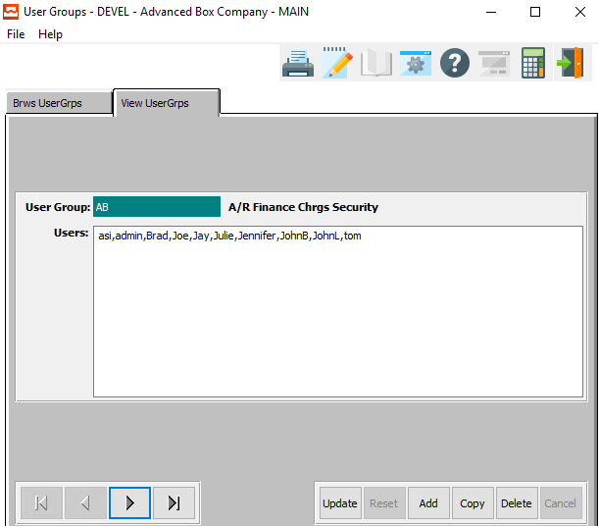

#### Add

Click the ***“Add”*** button on the *View User Groups* tab to add a new User Group and the User ID’s within it..

#### Update

Click the ***“Update”*** button on the *View User Groups* tab to add or remove User ID’s within the currently selected User Group.

## Security Access by Menu [NS6]

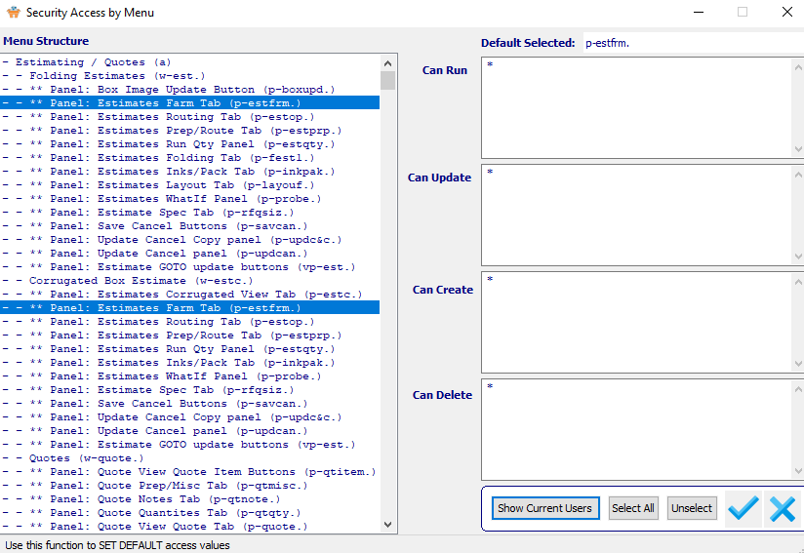

### Choose Menus

The user may choose their desired *Security Access Menu* by clicking on it to highlight it within the list of available Menus. To choose multiple menu options, the user can use the ***“Control-Click”*** method.

Highlighted programs can all have their security updated at once in order to save time.

### Update Security

An asterisk (*) within any of these fields means that everyone can access that portion of the program.

#### Can Run

The *Can Run* section is to set up who can view the data within the *Estimates Farm Tab* program.

#### Can Update

The *Can Update* section is security for who can update existing data within the *Estimates Farm Tab*.

#### Can Create

The *Can Create* section is security for who can add data within the *Estimates Farm Tab* program.

#### Can Delete

The *Can Delete* section is security for who can delete existing data within the *Estimates Farm Tab*.

# **Security for Notes**

## Program Master [NS8]

### Browse Programs

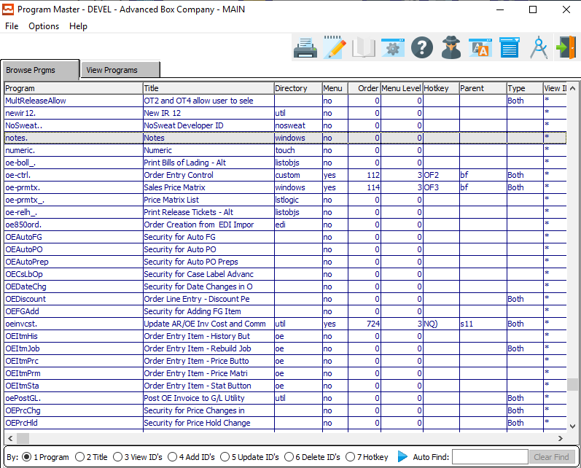

The user can search for their desired program by using the *Auto Find* search box at the bottom of the screen.

Security for *Notes* can be found within the (notes. ) program. This program specifically grants security access to the main information for Purchase Orders. Security for individual PO Lines uses a different program.

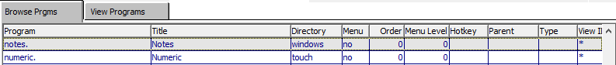

One the system administrator has highlighted their desired program within the list, they may set security by either *User Group* or *User ID* view the *View Programs* tab.

Please Note: *User Groups* are best.

### View Programs

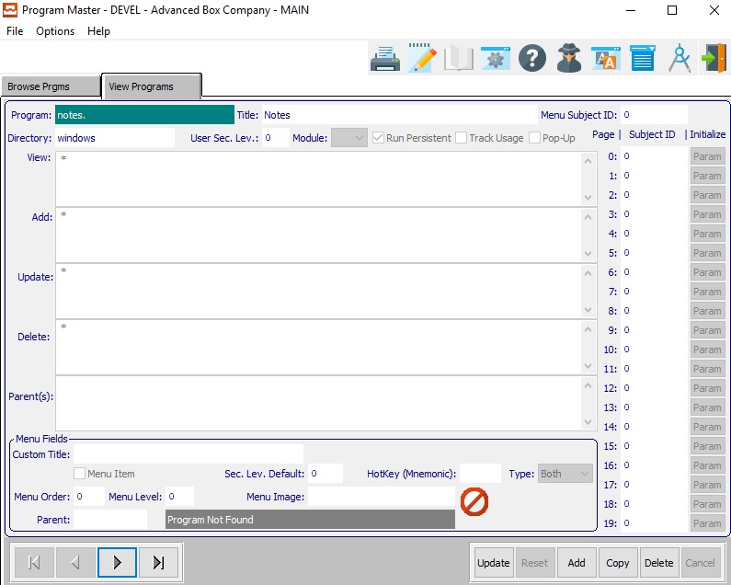

An asterisk (*) within any of these fields means that everyone can access that portion of the program.

#### View ID’s

The *View ID’s* is to set up who can view the data within the currently selected program.

#### Add ID’s

The *Add ID’s* is security for who can add data within the currently selected program.

#### Update ID’s

The *Update ID’s* is security for who can update existing data within the currently selected program.

#### Delete ID’s

The *Delete ID’s* is security for who can delete existing data within the currently selected program.

### User Groups

Under ***“N”-“U”-“5”***, the user can add groups, and assign users to that group. Then, if a user is hired or fired, the system administrator may simply change the users within the group that the employee belongs to. Therefore, no security will need to be changed.

If a user does not have access, the selected button will be grayed out.